Fundamentals of Data Science - Lab Manual (DSA0406)

7. Scenario: You are working as a data analyst for an e-commerce company. You have been given a dataset containing information about customer orders, stored in a Pandas DataFrame named order_data. The DataFrame has columns for customer ID, order date, product name, and order quantity. Your task is to analyze the data and answer specific questions about the orders.
Question: Using Pandas DataFrame operations, how would you find the following information from the order_data DataFrame:
1. The total number of orders made by each customer.
2. The average order quantity for each product.
3. The earliest and latest order dates in the dataset.
INPUT:
import pandas as pd
order_data = pd.DataFrame({
'Customer_ID': [101, 102, 101, 103, 102],
'Order_Date': ['2026-01-05', '2026-01-10',
'2026-02-15', '2026-02-20', '2026-03-01'],
'Product_Name': ['Laptop', 'Mouse', 'Mouse',
'Keyboard', 'Laptop'],
'Order_Quantity': [1, 2, 3, 1, 2]
})
order_data['Order_Date'] = pd.to_datetime(order_data['Order_Date'])
customer_orders = order_data.groupby('Customer_ID').size()
product_average = order_data.groupby('Product_Name')['Order_Quantity'].mean()
earliest_date = order_data['Order_Date'].min()
latest_date = order_data['Order_Date'].max()
print("Total orders by each customer:")
print(customer_orders)
print("\nAverage order quantity for each product:")
print(product_average)
print("\nEarliest order date:", earliest_date.date())
print("Latest order date:", latest_date.date())
OUTPUT:
Total orders by each customer:
Customer_ID
101 2
102 2
103 1
dtype: int64
Average order quantity for each product:
Product_Name
Keyboard 1.0
Laptop 1.5
Mouse 2.5
Name: Order_Quantity, dtype: float64
Earliest order date: 2026-01-05
Latest order date: 2026-03-01

8. Scenario: You are a data scientist working for a company that sells products online. You have been tasked with analyzing the sales data for the past month. The data is stored in a Pandas data frame.
Question: How would you find the top 5 products that have been sold the most in the past month?
INPUT:
import pandas as pd
data = {
'Product': ['Laptop', 'Mouse', 'Laptop', 'Keyboard',
'Mouse', 'Mobile', 'Tablet', 'Mobile'],
'Quantity': [10, 50, 15, 30, 40, 25, 12, 20],
'Date': ['2026-10-02', '2026-10-03',
'2026-10-05', '2026-10-06',
'2026-10-08', '2026-10-10',
'2026-10-12', '2026-10-15']
}
df = pd.DataFrame(data)
df['Date'] = pd.to_datetime(df['Date'])
# Filter sales for the past month
end_date = pd.Timestamp.today().normalize()
start_date = end_date - pd.DateOffset(months=1)
monthly_data = df[
(df['Date'] >= start_date) &
(df['Date'] <= end_date)
]
# Find the top 5 products
top_products = (
monthly_data.groupby('Product')['Quantity']
.sum()
.sort_values(ascending=False)
.head(5)
)
print("Top 5 Best-Selling Products:")
print(top_products)
OUTPUT:
Top 5 Best-Selling Products:
Product
Mouse 90
Keyboard 30
Laptop 25
Mobile 25
Tablet 12
Name: Quantity, dtype: int64

9. Scenario: You work for a real estate agency and have been given a dataset containing
information about properties for sale. The dataset is stored in a Pandas Data Frame named
property_data. The DataFrame has columns for property ID, location, number of bedrooms, area in square feet, and listing price. Your task is to analyze the data and answer specific questions about the properties.
Question: Using Pandas DataFrame operations, how would you find the following information from the property_data DataFrame:
1. The average listing price of properties in each location.
2. The number of properties with more than four bedrooms.
3. The property with the largest area.
INPUT:
import pandas as pd
property_data = pd.DataFrame({
'Property_ID': [101, 102, 103, 104, 105],
'Location': ['Chennai', 'Bangalore', 'Chennai',
'Mumbai', 'Bangalore'],
'Bedrooms': [3, 5, 4, 6, 5],
'Area': [1500, 2500, 2000, 3000, 2200],
'Price': [5000000, 8000000, 6500000,
9000000, 7500000]
})
avg_price = property_data.groupby('Location')['Price'].mean()
print("Average listing price by location:")
print(avg_price)
count = (property_data['Bedrooms'] > 4).sum()
print("\nProperties with more than 4 bedrooms:", count)
largest = property_data.loc[property_data['Area'].idxmax()]
print("\nProperty with the largest area:")
print(largest)
OUTPUT:
Average listing price by location:
Location
Bangalore 7750000.0
Chennai 5750000.0
Mumbai 9000000.0
Name: Price, dtype: float64
Properties with more than 4 bedrooms: 3
Property with the largest area:
Property_ID 104
Location Mumbai
Bedrooms 6
Area 3000
Price 9000000
Name: 3, dtype: object

10. Scenario: You are working on a data visualization project and need to create basic plots using Matplotlib. You have a dataset containing the monthly sales data for a company, including the month and corresponding sales values. Your task is to develop a Python program that generates line plots and bar plots to visualize the sales data.
Question:
1. How would you develop a Python program to create a line plot of the monthly sales data?
2: How would you develop a Python program to create a bar plot of the monthly sales data?

INPUT:
1)Line Plot:
import matplotlib.pyplot as plt

months = ['Jan', 'Feb', 'Mar', 'Apr', 'May', 'Jun']
sales = [10000, 15000, 12000, 18000, 20000, 25000]

plt.plot(months, sales, marker='o')

plt.title("Monthly Sales")
plt.xlabel("Months")
plt.ylabel("Sales")

plt.show()
OUTPUT:
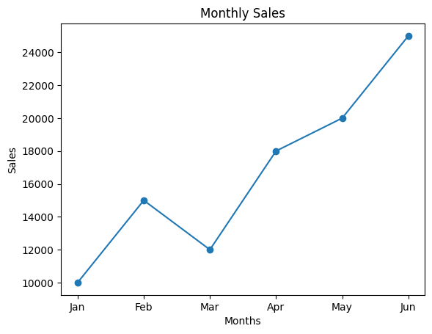

2)Bar Plot:
import matplotlib.pyplot as plt

months = ['Jan', 'Feb', 'Mar', 'Apr', 'May', 'Jun']
sales = [10000, 15000, 12000, 18000, 20000, 25000]

plt.bar(months, sales)

plt.title("Monthly Sales")
plt.xlabel("Months")
plt.ylabel("Sales")

plt.show()
OUTPUT:

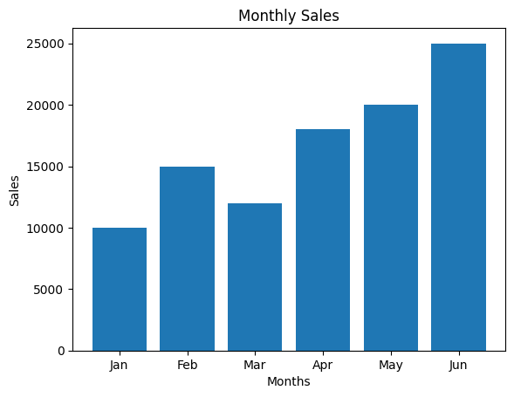
11. Scenario: You are a data scientist working for a company that sells products online. You have been tasked with creating a simple plot to show the sales of a product over time.
Question:
1. Write code to create a simple line plot in Python using Matplotlib to predict sales happened in a month?
2. Write code to create a scatter plot in Python using Matplotlib to predict sales happened in a
month?
3. Develop a Python program to create a bar plot of the monthly sales data.
INPUT:
1)Line Plot:
import matplotlib.pyplot as plt
months = ['Jan', 'Feb', 'Mar', 'Apr', 'May', 'Jun']
sales = [10000, 15000, 12000, 18000, 20000, 25000]
plt.plot(months, sales, marker='o')
plt.title("Monthly Product Sales")
plt.xlabel("Months")
plt.ylabel("Sales")
plt.show()
OUTPUT:
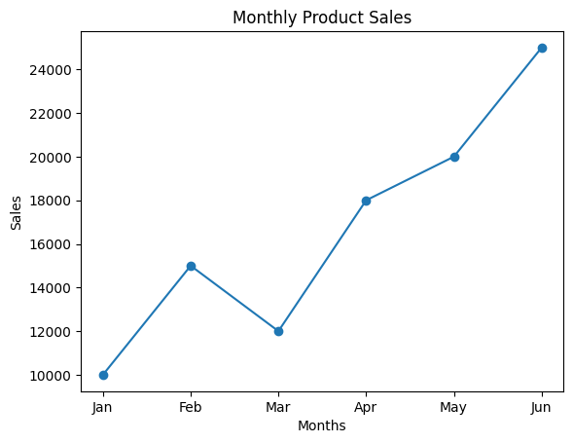

2)Scatter Plot:
import matplotlib.pyplot as plt

months = ['Jan', 'Feb', 'Mar', 'Apr', 'May', 'Jun']
sales = [10000, 15000, 12000, 18000, 20000, 25000]

plt.scatter(months, sales)

plt.title("Monthly Product Sales")
plt.xlabel("Months")
plt.ylabel("Sales")

plt.show()
OUTPUT:
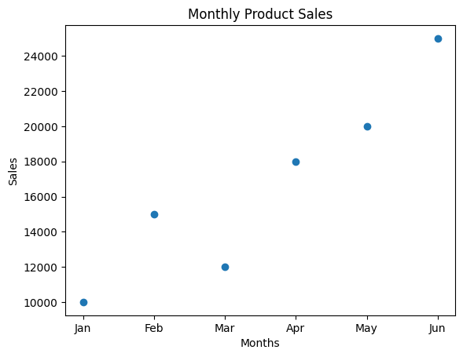

3)Bar Plot:
import matplotlib.pyplot as plt

months = ['Jan', 'Feb', 'Mar', 'Apr', 'May', 'Jun']
sales = [10000, 15000, 12000, 18000, 20000, 25000]

plt.bar(months, sales)

plt.title("Monthly Product Sales")
plt.xlabel("Months")
plt.ylabel("Sales")

plt.show()
OUTPUT:
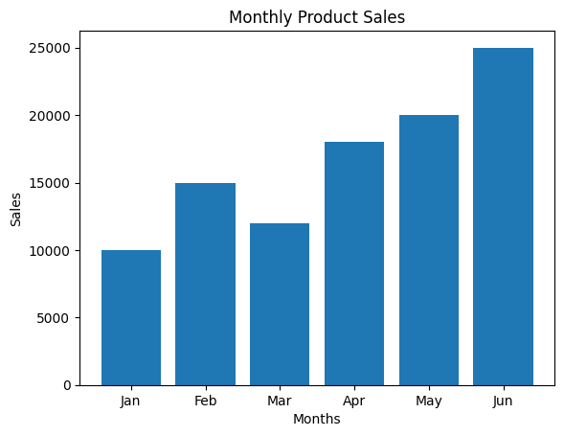

12. Scenario: You are working on a data analysis project that involves analyzing the monthly temperature and rainfall data for a city. You have a dataset containing the monthly temperature and rainfall values for each month of a year. Your task is to develop a Python program that generates line plots and scatter plots to visualize the temperature and rainfall data.
Question:
1. Develop a Python program to create a line plot of the monthly temperature data.
2: Develop a Python program to create a scatter plot of the monthly rainfall data.

INPUT:
1)Line Plot:
import matplotlib.pyplot as plt

months = ['Jan', 'Feb', 'Mar', 'Apr', 'May', 'Jun',
'Jul', 'Aug', 'Sep', 'Oct', 'Nov', 'Dec']

temperature = [22, 24, 27, 30, 33, 31,
29, 28, 27, 26, 24, 22]

plt.plot(months, temperature, marker='o')

plt.title("Monthly Temperature")
plt.xlabel("Months")
plt.ylabel("Temperature (°C)")

plt.show()
OUTPUT:
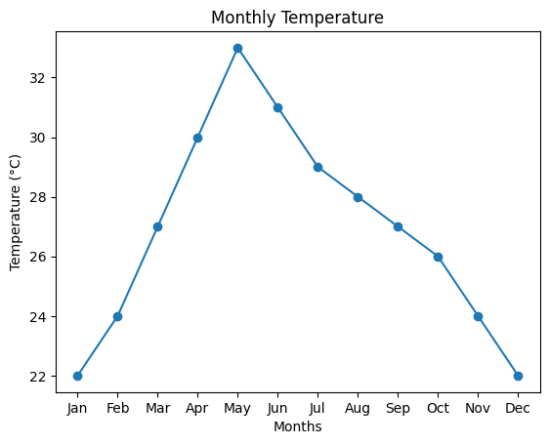

2)Scatter Plot:
import matplotlib.pyplot as plt

months = ['Jan', 'Feb', 'Mar', 'Apr', 'May', 'Jun',
'Jul', 'Aug', 'Sep', 'Oct', 'Nov', 'Dec']

rainfall = [20, 25, 40, 60, 100, 150,
180, 160, 120, 90, 50, 30]

plt.scatter(months, rainfall)

plt.title("Monthly Rainfall")
plt.xlabel("Months")
plt.ylabel("Rainfall (mm)")

plt.show()
OUTPUT:


